Numerical Linear Algebra ----MatLab

Sep 20 2011

Implements the following experiments and paste the numerical results and matlab commands at each step of the experiments.

* Matrices and linear equations

1. Produce two matrices

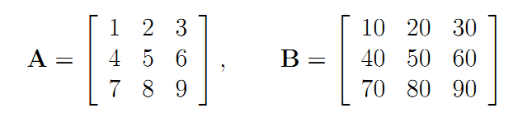.

1. The array operations are given as follows:

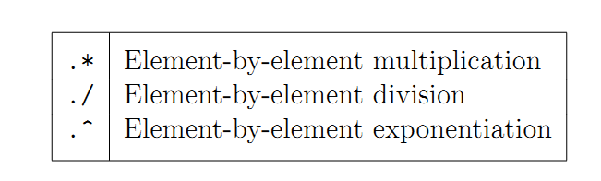

1. The matrix operations are given as follows:

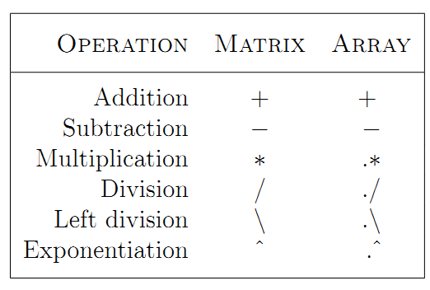

1. Compute A\*B, A.\*B, A./B, A.^2, A.^B.
2. Convert the following linear system into a matrix multiplication AX =b

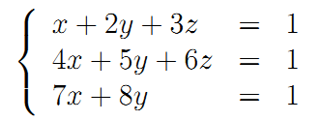.

1. Solve it by calculating the inverse of the system matrix A;
2. Use \ to solve the linear system.
3. Use the online helps to find how to use these functions

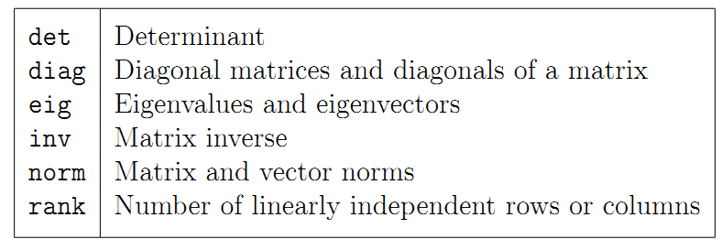.

Calculate det(A), diagonals of A, a diagonal matrix through using diag to set diagonal elements as the first column elements of A), the 2-norm and Frobenius norms of A and 1-norm of A(:), and the rank of A.

1. Find the trace of A.(use online help).

* Experiment 1: Discrete Legendre Polynomials

1. Create a Vandermonde matrix A by discretizing [-1, 1] by 257 equally spaced points.
2. Find is the reduced QR factorization of A (use the matlab commond qr and read the online helps on qr).
3. Rescale the matrix Q by the last the row of Q. Plot the columns of the rescaled Q on a figure.

* Experiment 2: Classical vs. Modified Gram-Schmidt (read the textbook)

1. Set U and V to random orthogonal matrices. (see textbook)
2. Set a diagonal matrix S with exponentially graded entries S = diag(2.^(-1:-1:-80)).
3. Set A = USV.
4. Compute QR factorization by using the classic and modified Gram-Schmidt (Use matlab commands clgs and mgs. Read the online helps of each command).
5. Plot the diagonal elements rjj produced by both computations on a logarithmic scaled figure.
6. Summarize the observations from the figure? What does cause the different plots of Classical and Modified Gram-Schmidt?

* Experiment 3: Numerical loss of orthogonality

1. Generate a rank-deficient matrix as follows:

A = [0.7000, 0.7011; 0.70001, 0.70711 ];

1. Compute the QR factorization by using the matlab command qr.
2. Compute the QR factorization by using Modified G-S.
3. Test the orthogonality of Q matrices obtained from step 2 and 3 respectively. Make your conclusion based on the observations of the orthogonality tests.